TXShare Online Remuneration Process
Greetings! As a partnered vendor of TXShare, we sincerely appreciate you and your organization for the goods and services provided to the public sector! TXShare is growing day-by-day, and in part of that we have decided to implement a new quarterly remuneration reporting process that is more user-friendly to you. We are continuously looking for new ways to make our processes better, and this new reporting format is heavily inspired by the feedback received from our vendors over the past few quarters. We are ever developing, so if you have any concerns/questions, you can always reach us at our TXShare inbox. Thank you again for your public service, and you can find the recommended steps to completing this new remuneration report below.

- Please access the first page of the new report here: https://app.smartsheet.com/b/form/2f26a8f4d449406ebb00037fde68245c
- A new tab on your preferred browser should open with the first page of the report. You will see a window similar to the following screenshot:

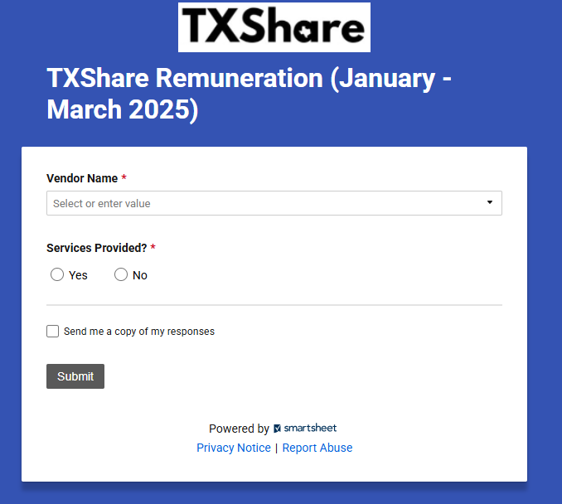

- Please find and select your organization’s name under the drop-down list for Vendor Name and select if you received payment for any usage of your TXShare contract for the outlined date.
  - If you click “yes” additional fields will appear for you to report on your first 5 entity spends for the quarter. (There is only room to report on 5 entities for each form – if you have more than 5, you will submit the form as many times as needed)
  - If you click “no” a submit button will appear, click that submit button and exit out of the screen that appears (page 2).

- After completing the first page and hitting submit, you will see a window similar to the following:

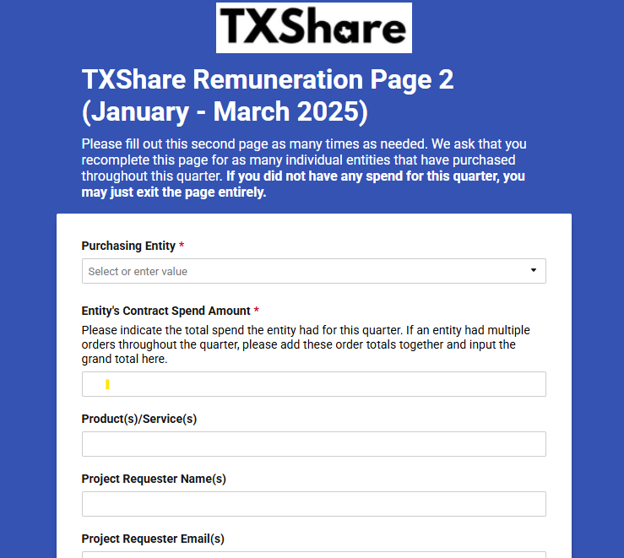

- We have designed this second page to be filled out for only 5 purchasing entities at a time. In other words, if you have more entities that have purchased from your organization than that over the past quarter, we ask that you recomplete this second page for each additional 5 entities you are reporting for.
- In the first item box labeled Purchasing Entity, please select the entity that you want to first report for in the drop-down menu.
Please note that the entities included in this menu are ever changing as we acquire new members, if you do not see the organization you are searching for, just type it in and the report will capture your submission.

- After completing this first box, please input the accumulated spend that specific entity has totaled for the quarter into the Entity’s Contract Spend Amount. If an entity has multiple transactions or purchased several times throughout the quarter, we ask that you input the total sum of all separate purchases into one grand total for that entity.

- In the Product/Service box, you may indicate the various products and/or services the entity has procured over the quarter. The intent behind this box is to gather more insight on what specific goods an entity may be procuring. This helps on our side to better market your organizations’ products or services that may fit a particular audience! This box is not required however, so if there is no feasible way to input this information, you may move on to the next item.

- In the Project Requester Name box, you may input the entity’s primary contact(s) who directed their respective procurement from your organization. Again, this box is not required so if there is no contact or no feasible way to input this information, you may move on to the final item.

- In the Project Requester Email box, you may input the corresponding point contact’s email if available. Again, this is not required to complete the form.

- Once you have verified your information for that entity and are ready to move on, you may hit the submit button at the bottom. You’ll then be taken to a clean version of the second page once again. As stated before, this second page is meant to encompass each entity separately. If you have another entity to report for, please recomplete the form using steps 6-10.

- After you have completed this second page for each entity you have reported spend for throughout the quarter, you may hit submit for the final entity and exit out of the tab/browser entirely once it has processed.
If you must exit the form in between entities for whatever reason, you may click the link in step 1 to return to the beginning of the form. You will have to recomplete this first page with your organization’s information, but you may begin on the next entity where you had left off from the previous session. Otherwise, once you have submitted the information for your final entity and have clicked submit, you are finished reporting for this quarter!

As mentioned before, TXShare is continuously looking for ways to better our processes and service to both our vendors and members. This new form is a reflection of the dedication we hold to foster a better relationship between your organization and ourselves! We also understand that because this is a new process, there may be some questions along the way, and we are here to help. Please feel free to reach out either to the TXShare inbox or to TXShare Business Services Manager Mandy Collett with any questions or concerns you may have. Additionally, a copy of the previous Excel reporting form will also be provided if that option is still preferred. Once again, we thank you for your service to the public, and we look forward to continuing a beneficial and prosperous partnership.

